Unix is a CUI – Operating System

CUI – Character User Interface

Unix – is the multi – user operating system (highly secured) -- very rare virus attacks

Unix – Commands are very powerful

Both Linux & Mac Operating System is based on unix operating System only.

Windows OS is based on DOS operating system

DOS – Disk Operating System – (MS-DOS)

If you want to execute unix commands, either you need Linux/Mac operating System.

If you like to execute unix commands from windows OS, then

1. Using Cygwin – it’s a tool using which we can download all the linux based applications/software and execute them from windows.
2. Using Git-Bash – (<https://git-scm.com/download/win> -- file name : [**64-bit Git for Windows Setup**](https://github.com/git-for-windows/git/releases/download/v2.35.1.windows.2/Git-2.35.1.2-64-bit.exe)**. )**

WSL – Windows SubSystem for Linux – Virtual Machines (Linux/Mac using Hyper-V)

Docker – Pre-requirement (WSL2) – virtualization options

In unix

/ - It represents root directory

In dos

C: - System Drive (Operating System & Other related files will be installed in this drive only)

Git-Bash

Bash – Bourne again shell.

Git-Bash :

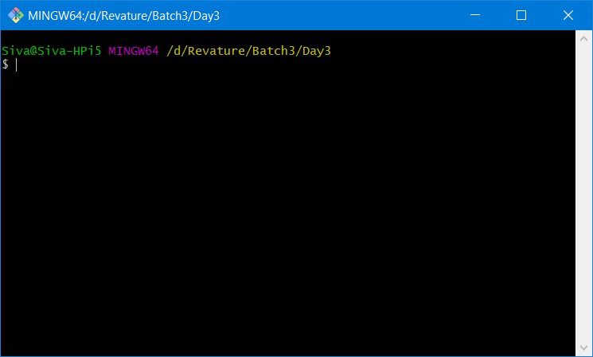

Difference between Terminal/Bash/Command Prompt

In dos – Command prompt (dos commands .bat (batch file), .cmd (command file))

In unix – Bash (.sh) – shell script file

In Mac – Terminal .dmg

Basically all these three are used to execute commands.

Creating a new file in dos command prompt

Copy con siva.bat

Dir

Date

Time

(Ctrl+Z) ^z (press Enter key)

1 file(s) copied

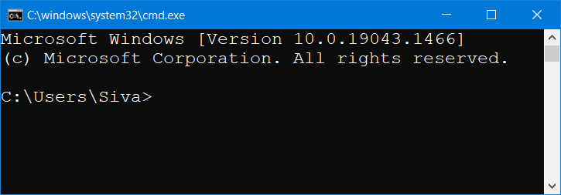

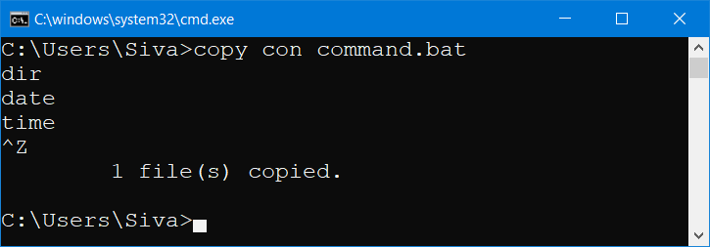

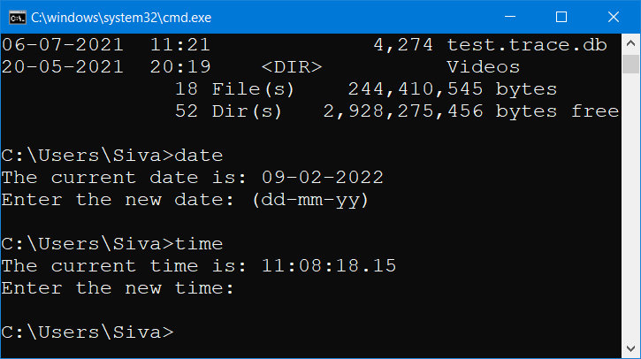

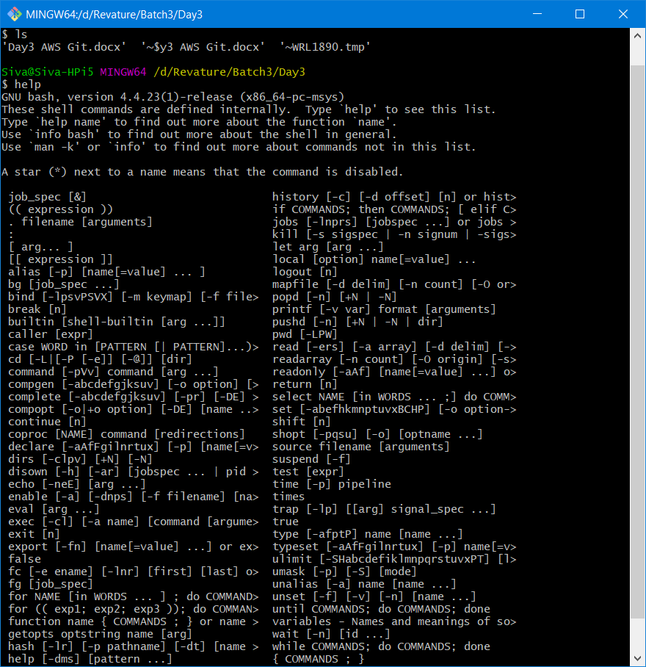

Type “info” in Cygwin-bash

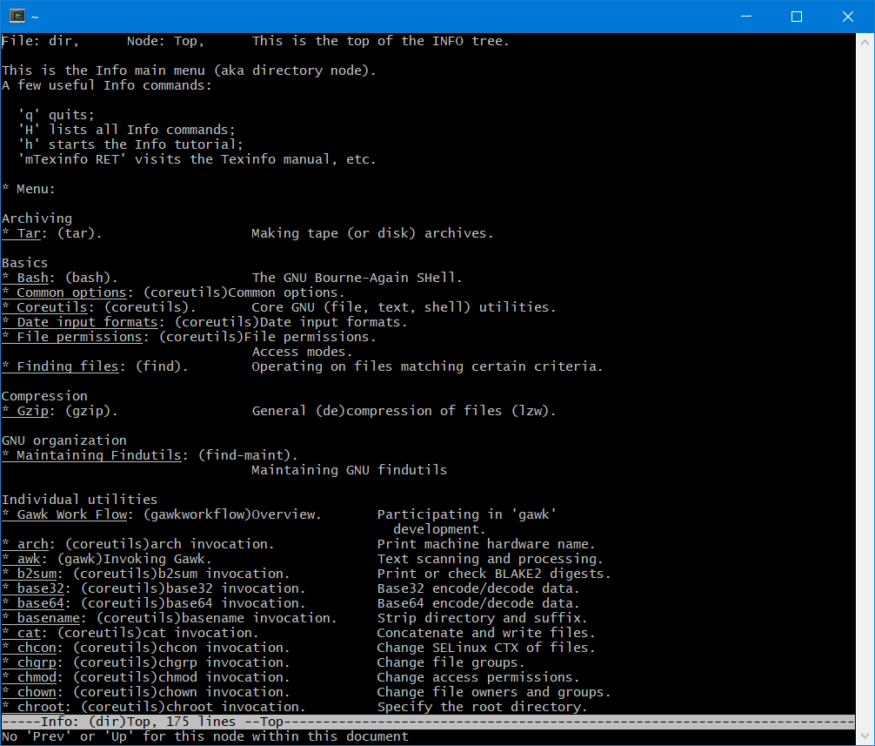

Important Unix commands

1. ls - To list all the files and folders in current directory
2. man cp

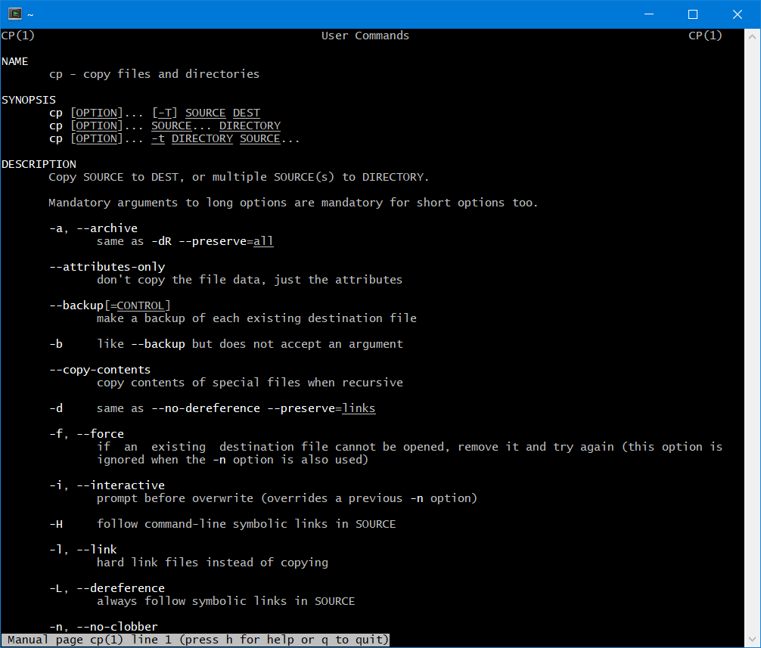

1. pwd – print working directory

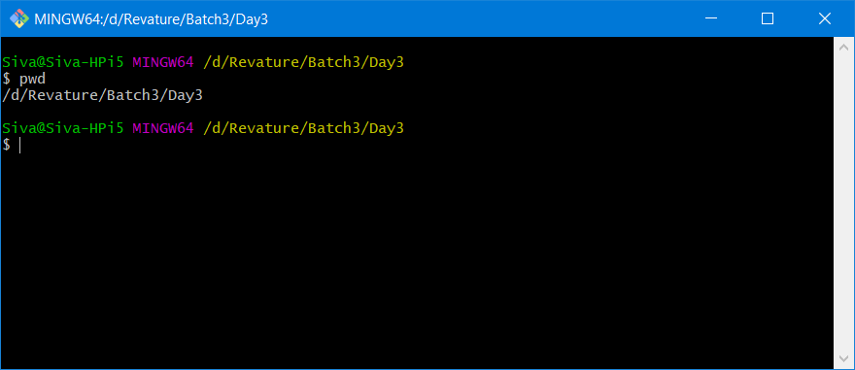

1. cd .. to navigate one folder above

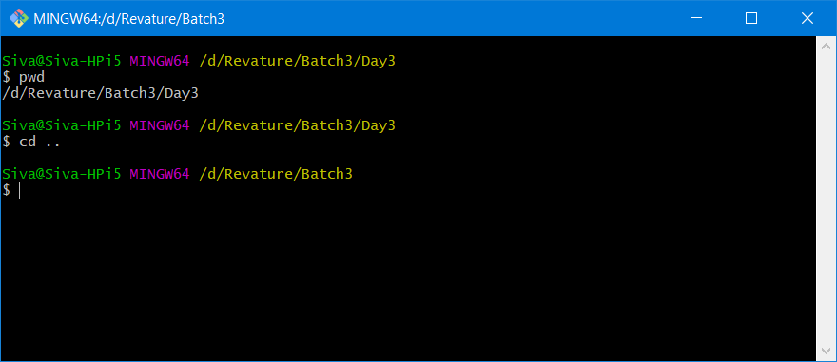

1. cd / -navigate to root folder

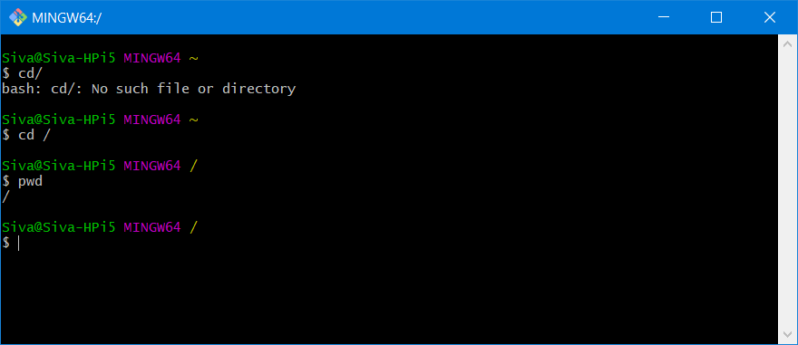

1. man ls

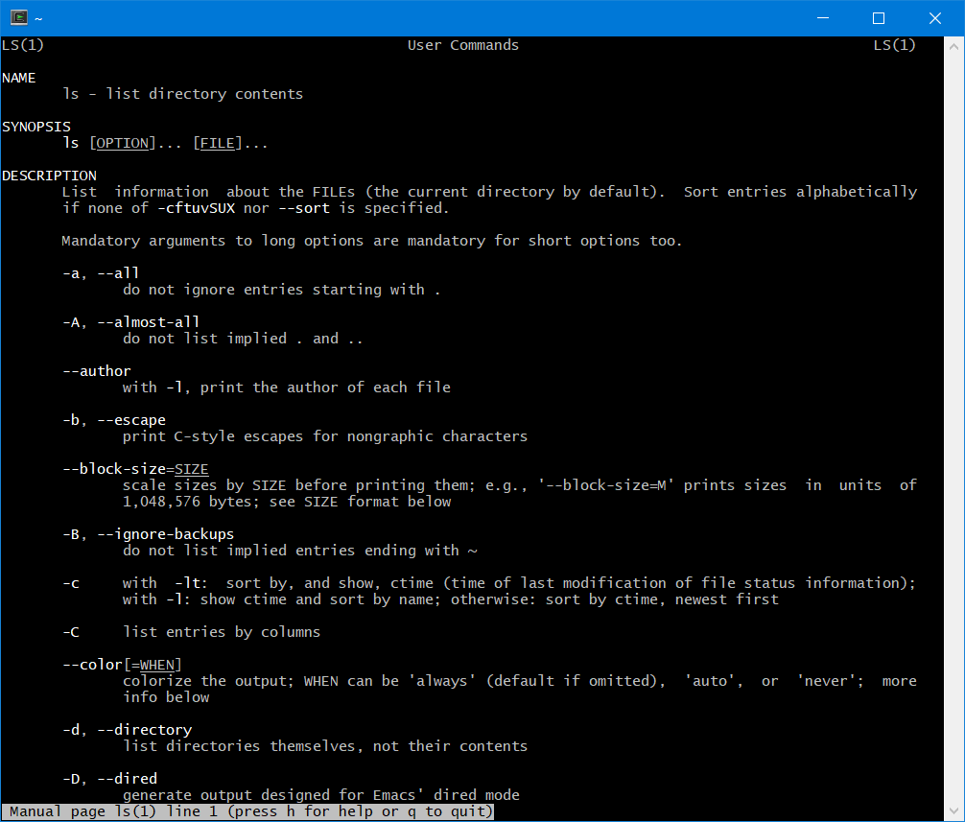

1. mkdir myFolder – To Create a new folder (directories)

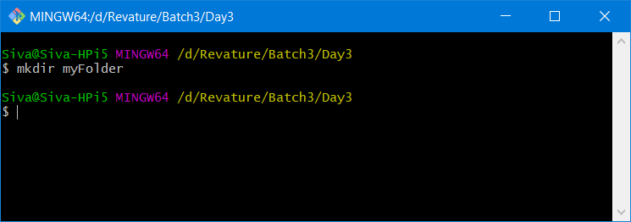

1. cd myFolder

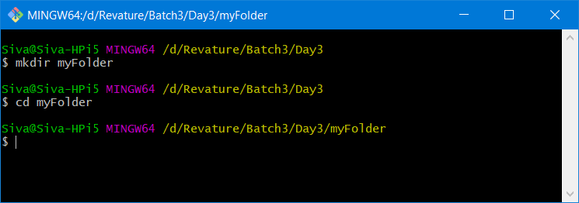

1. clear -to clear the screen

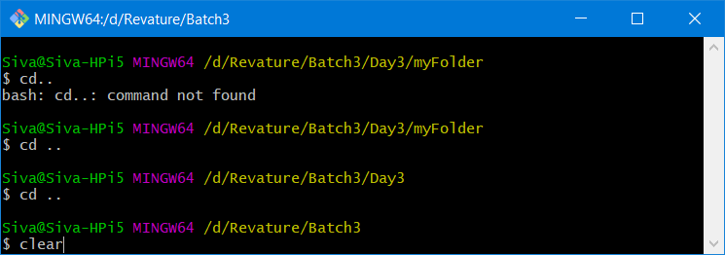

1. echo “any String” -- This command is used to print the string or variable.

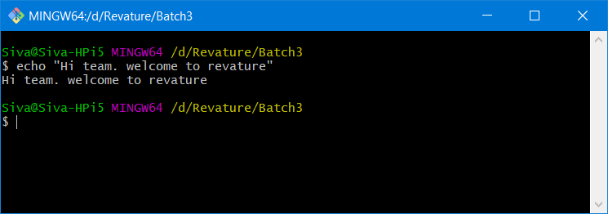

1. ls . > log.txt -- This command redirects the output of ls . to a file named log.txt

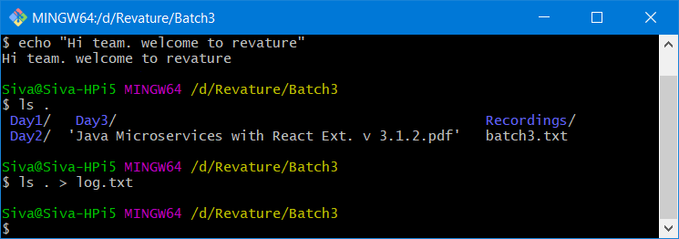

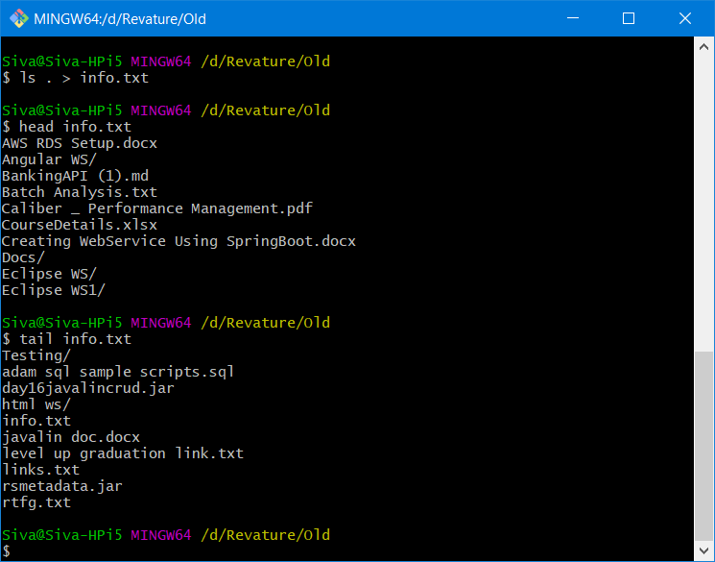

Git – Distributed Version control System

Version control system – it is a way to maintain track of all the changes that happened in a particular folder.

ProjectFolder/

Git – popular, open source, distributed version control system

It can be accessible with the help of git commands.

Git clone <repo_url>

Git commit -m “First Commit” -- Saving the changes to the repository permanently

Git add – will help to add file/folder to git repository

<http://Git-scm.com> – Official site for Git-SCM

Repository – Is nothing but a folder that maintains/tracks all the changes

Local Repository – Is a folder that contains .git folder

To initialize an empty git local repo, use the following command

“git init”

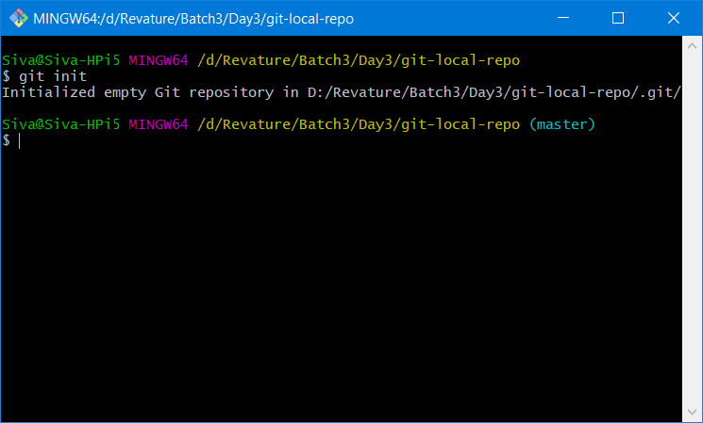

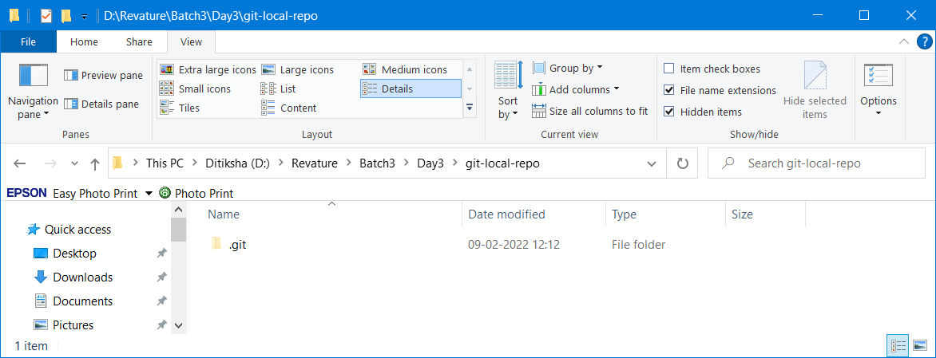

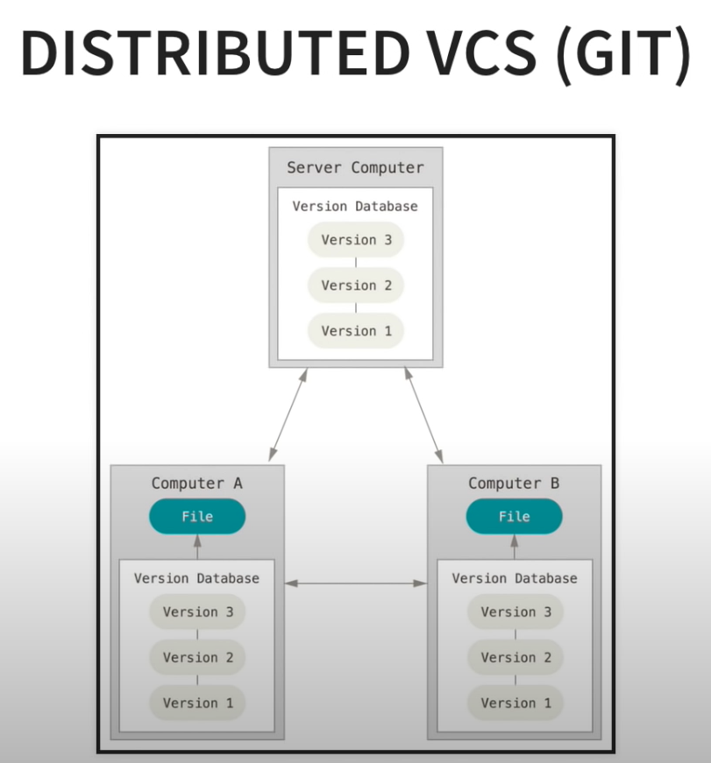

**2. See hidden files on Mac via Finder**

As mentioned above, it doesn’t take much to make the hidden files on your Mac visible. In fact, you can check out all of the hidden files on your Mac by following just three easy steps:

1. In Finder, open up your Macintosh HD folder
2. Press Command+Shift+Dot
3. Your hidden files will become visible. Repeat step 2 to hide them again!

This process will also work elsewhere, including your Documents or Applications folders. However, if you know what you’re looking for is in your ~/Library folder and would rather jump straight into that then you can take the following steps instead:

1. In Finder, hold down Alt and click Go at the top of your screen
2. Click on Library to open up the, normally hidden, folder

Git add . – This command will add all the files to the staging area (Git can track all the files now)

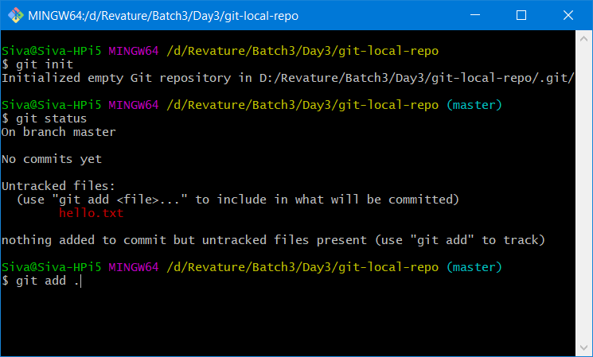

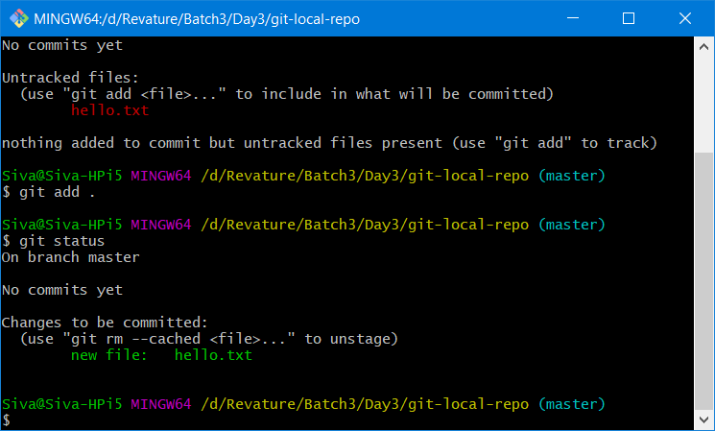

Git-SCM:

**Source code management** (SCM) is used to track modifications to a source code repository. SCM tracks a running history of changes to a code base and helps resolve conflicts when merging updates from multiple contributors.

Git status -- To get more info about the local-repo (It will display all tracked & un-tracked files)

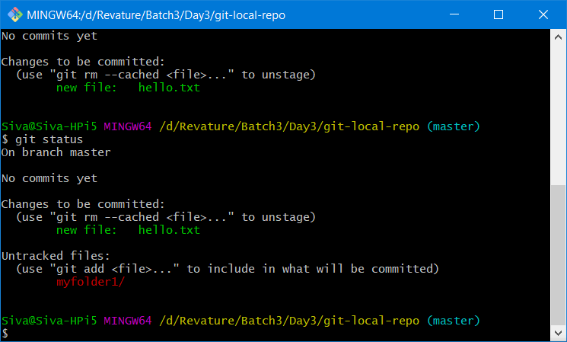

To open git-gui (Graphical user interface)

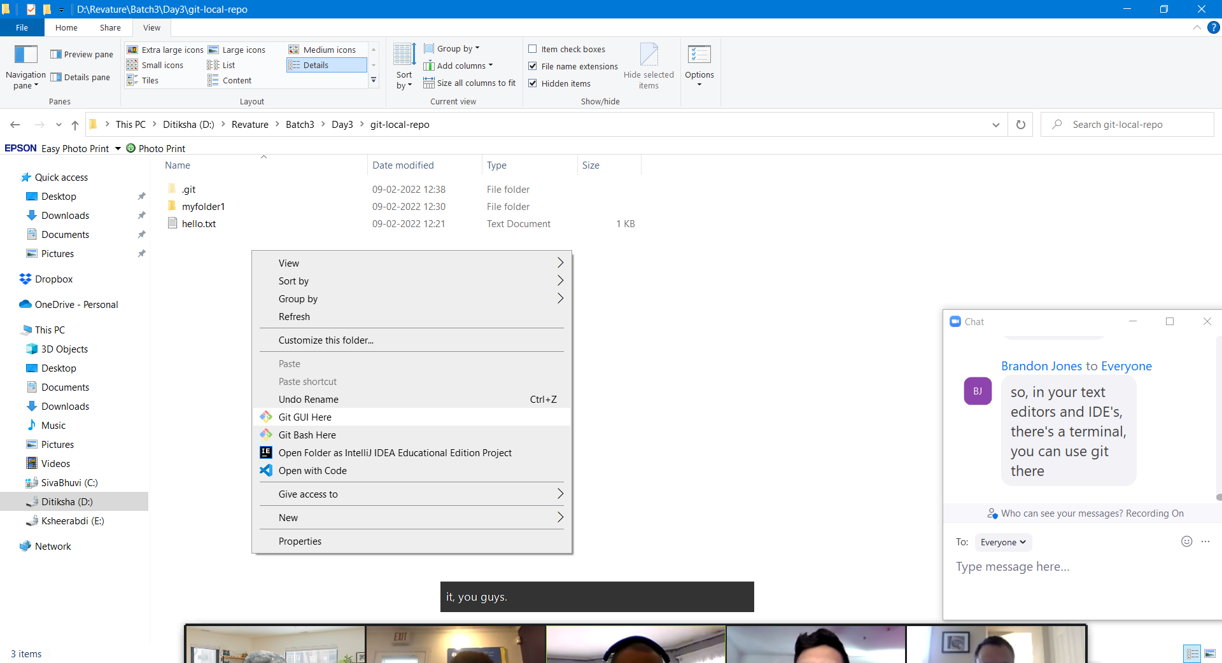

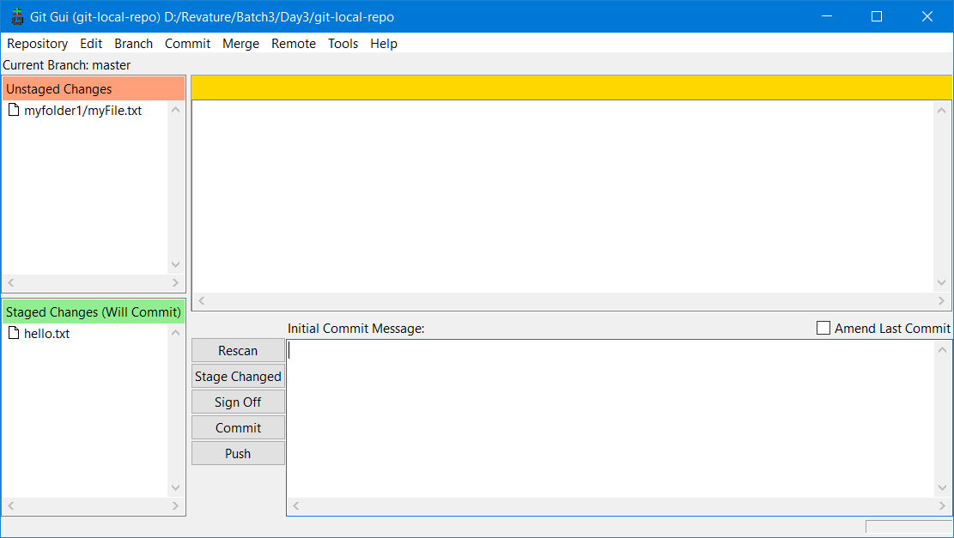

*** Git will not track empty files & folders

In Git, there are three area

1. Staging area (Temporary area) -
2. Local- repo ( Location/Folder in a file system )
3. Remote-repo (It’s a web space to store and track all the files of your project) – Github

Difference between git & github

Git – Command line tool for version control

Github – Web Application (cloud based) where we can store/manage the source code of any project

* 1. Dos – Operating System (CUI – every operation is performed with the help of commands)
  2. Unix – Operating System (CUI – Character User Interface)
  3. Windows – Operating System – based on DOS – GUI – Graphical User Interface (Proprietary OS) – pay to use. Microsoft
  4. Linux – Operating System (Open Source) – free to use , many companies , distributions (Redhat, ubuntu, suse, kali, fedora…)

GIT – Is a version control tool

1. Git -bash (CUI)
2. Git-GUI (Graphical user interface of the same tool)

Myfile.txt

Day 1 -- some contents ….. and saving it. File size : 4kb

Day 2 .. adding few more contents to it, & saving it. File size: 7kb

Day 3 --- adding few more contents and deleting few line (in appropriate) and saving it FileSize:12kb

Tracking the changes to a file/folder – version controlling.

SVN, CVS, Perforce, clearcase – version control tools

Git add .

Git commit -m “first commit”

Git push

Git status

Git log

Git checkout

Git branch

Git is developed by a person named linus Torvalds